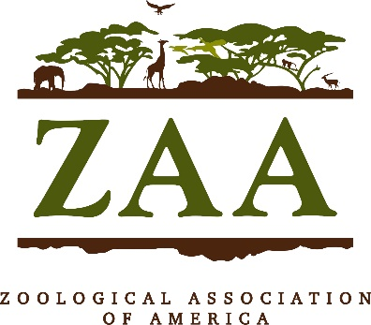

Zoological Association of America

Conservation Fund Grant 2024

The Zoological Association of America (ZAA) is committed to the conservation of endangered species and their habitats worldwide. The ZAA Conservation Fund awards grants up to US $5,000 to help in this effort. A wide variety of proposals will be considered, however field programs, studies and multidisciplinary approaches to species conservation, habitat preservation, and biodiversity enhancement are encouraged. Programs that directly contribute to species and habitat conservation including ex situ research, as well as rescue and rehabilitation of injured or ill animals will also be considered.
Submission Guidelines:
- ZAA preferentially funds conservation projects for wild animal species, populations, habitats, and promotion of biodiversity that:
  - Are globally threatened or data deficient (taxa being evaluated and assessed by the IUCN red list (www.iucnredlist.org) in the categories: DD (data deficient), VU (vulnerable), EN (endangered), CR (critically endangered) or EW (extinct in the wild)
  - Are little known or not the major focus of any other conservation programs or conservation organizations.
- Potentially eligible are specific conservation and research measures that directly contribute to the survival of a species-/subspecies-/population, preferably in its natural range. Also potentially eligible are programs of ex situ research and/or rescue that have direct implications for conservation of species in the wild.
- The principal investigator must be associated with a recognized institution (accredited zoo, academic institution, conservation, or non-profit organization).
- Only electronic submissions will be accepted.
- Grant requests may range from $1,000 to $5,000.
- All applicants MUST submit their 1-2 page Curriculum Vitae. Other documents relevant to the proposal may also be included, such as an endorsement letter from a range country, maps, relevant publications, program and/or study objectives and timelines.

Each proposal must include the following items for consideration:

i) Outline of the project and, if appropriate, work completed to date.

- The outline should include an overview of the project, the study objectives and projected outcomes, a map of the study range, and the timeline of the project.
ii) The aspects of the project that will be funded by this grant.
(1) If the ZAA Conservation Grant amount does not cover the entire project cost, how will the rest of the project be funded?
(2) What happens to the project if sufficient funding is not generated?
iii) An endorsement letter(s) for the project preferably from a representative knowledgeable about the project from the range country of the project.
iv) A one-to-two-page Curriculum Vitae for each of the primary researchers involved with the project.
v) Relevant publications.
vi) Please submit your application in English.
7. Proposals should be five (5) pages or fewer, excluding literature citations and appendices.
8. A semi-annual progress report is required six to eight months after receiving the grant. This report should include high-resolution images illustrating the project.
9. An annual or final report is required within one year after the grant period ends. This report must be specific to the purpose for which the Conservation Grant Fund was awarded, address the objectives identified within the project application, and include accounting for the grant funds provided by ZAA.
i) If the project does not commence within one year of the ZAA Conservation Grant, the funds may be requested to be returned to ZAA.
10. All recipients of grants agree that their reports (annual reports, status reports, any other documents, e.g. photos, multimedia, etc.) can be used unrestricted for publication in the ZAA Magazine and ZAA website or other media – except for information clearly marked as ‘confidential’.
11. All recipients of grants must acknowledge ZAA's support in any publication and in any public media presentation of the funded project. ZAA provides its logo for that purpose.
12. Proposals will be accepted from January 1, 2024 - April 15, 2024. ZAA will acknowledge receipt of your application by email, within two weeks of receipt. Decisions will be made by June 15, 2024 and funding will become available by June 30, 2024.

SEND APPLICATIONS AND ALL SUPPORTING MATERIALS ELECTRONICALLY TO:
info@zaa.org
Please keep a copy of your application for your records. In the process of adjudication, we may ask the applicant for further information. If funded, we may ask you to provide specific information from the completed application as proof that funds will be sent to the correct party.
Applicants will be contacted after June 15, 2024, regarding the selection of the projects.
For further information, please contact: info@zaa.org

