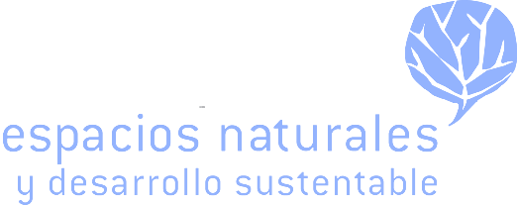

Peninsular Pronghorn Recovery Project

Project Area: Baja California and Baja California Sur, Mexico

Project Implementer: Espacios Naturales y Desarrollo Sustentable (Natural Spaces and
Sustainable Development)

Website: https://www.endesu.org.mx/programa-de-recuperacion-del-berrendo-peninsular/

The Peninsular Pronghorn Recovery Project’s (PPRP) primary objective is the conservation and
restoration of the peninsular pronghorn (Antilocapra americana peninsularis) to the desert
regions of the Baja California Peninsula and southern California. Currently all PPRP activities
take place within El Vizcaíno Biosphere Reserve and the Valle de los Cirios Flora and Fauna
Protection Area, in the Baja California Peninsula in Mexico. Due to expansion of agriculture and
extensive ranching along with unrestricted hunting, the peninsular pronghorn population had
decreased to fewer than 160 individuals by 1993 and was restricted to the Vizcaíno Biosphere
Reserve (SEMARNAT 2009).

In 1997 Espacios Naturales y Desarrollo Sustentable (ENDESU, or Natural Spaces and
Sustainable Development) initiated the PPRP with the establishment of a captive breeding
program with the goal of increasing the population of peninsular pronghorn through captive
breeding for eventual release to the wild. In 2004 AZA institutions such as the Los Angeles Zoo,
San Diego Zoo Global, and The Living Desert Zoo and Gardens provided husbandry,
management, and veterinary assistance to the PPRP that resulted in the increase of the captive
population to 56 individuals by 2020 and the establishment of an AZA SSP Program for the
species in the United States as an assurance population to the PPRP ex-situ program. The US ex-situ facilities has expanded to include the El Paso Zoo and Wildlife World Zoo & Aquarium.

As of 2020 the captive managed population in Baja was over 500 individuals with three reintroduction sites having been established. Despite the successes of the program the actual remaining wild population continued to decline to an estimated 25 individuals by 2015. Today the wild population in Mexico has increased to about 74 individuals because of supplementation of individuals from the PPRP captive population to the wild herd. This increase is notable, despite the documented slight annual decreases in rainfall in the area, likely due to climate change.

This remaining wild herd is far from secure and one of the PPRP objectives is to supplement and stabilize it to allow for an increase in population size and viability into the future. This will be achieved through the provision of (1) several secure water and providing forage in areas that exclude cattle (2) the addition of captive animals to this population to bolster their numbers and potential for long-term success, including facilitating expansions in their range and (3) monitoring of the released animals to determine how they use the fragmented habitat and where future reintroduction sites would best be located. Expanding area and population size are two easy ways to ensure the long-term viability of the population in this area.

